1. A close up of a sign

   Description automatically generated
2. 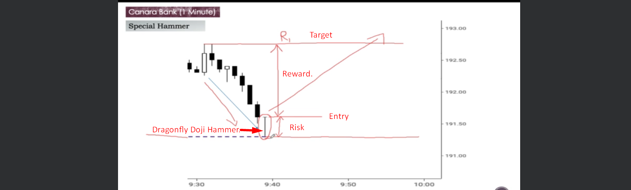
3. The below chart is 1 minute for intraday.A graph of a stock market

   Description automatically generated with medium confidence